Exercise 1: Implementing the Singleton Pattern

CODE:

public class SingletonPatternExample {  
 static class Logger {  
 private static Logger *instance*;  
 private Logger() {  
 System.*out*.println("Logger instance created.");  
 }  
 public static Logger getInstance() {  
 if (*instance* == null) {  
 *instance* = new Logger();  
 }  
 return *instance*;  
 }  
 public void log(String message) {  
 System.*out*.println("Log: " + message);  
 }  
 }  
 public static void main(String[] args) {  
 Logger logger1 = Logger.*getInstance*();  
 logger1.log("First log entry.");  
 Logger logger2 = Logger.*getInstance*();  
 logger2.log("Second log entry.");  
 if (logger1 == logger2) {  
 System.*out*.println("Only one instance of Logger is used.");  
 } else {  
 System.*out*.println("Different Logger instances exist!");  
 }  
 }  
 }

OUTPUT:

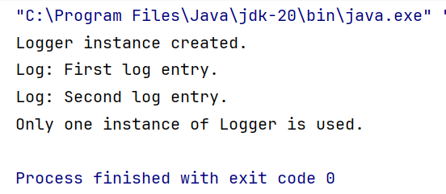

Exercise 2: Implementing the Factory Method Pattern

CODE:

public class FactoryMethodPatternExample {  
 interface Document {  
 void open();  
 }  
 static class WordDocument implements Document {  
 public void open() {  
 System.*out*.println("Opening a Word document.");  
 }  
 }  
 static class PdfDocument implements Document {  
 public void open() {  
 System.*out*.println("Opening a PDF document.");  
 }  
 }  
 static class ExcelDocument implements Document {  
 public void open() {  
 System.*out*.println("Opening an Excel document.");  
 }  
 }  
 abstract static class DocumentFactory {  
 public abstract Document createDocument();  
 }  
 static class WordDocumentFactory extends DocumentFactory {  
 public Document createDocument() {  
 return new WordDocument();  
 }  
 }  
 static class PdfDocumentFactory extends DocumentFactory {  
 public Document createDocument() {  
 return new PdfDocument();  
 }  
 }  
 static class ExcelDocumentFactory extends DocumentFactory {  
 public Document createDocument() {  
 return new ExcelDocument();  
 }  
 }  
 public static void main(String[] args) {  
 DocumentFactory wordFactory = new WordDocumentFactory();  
 Document wordDoc = wordFactory.createDocument();  
 wordDoc.open();  
 DocumentFactory pdfFactory = new PdfDocumentFactory();  
 Document pdfDoc = pdfFactory.createDocument();  
 pdfDoc.open();  
 DocumentFactory excelFactory = new ExcelDocumentFactory();  
 Document excelDoc = excelFactory.createDocument();  
 excelDoc.open();  
 }  
 }

OUTPUT:

